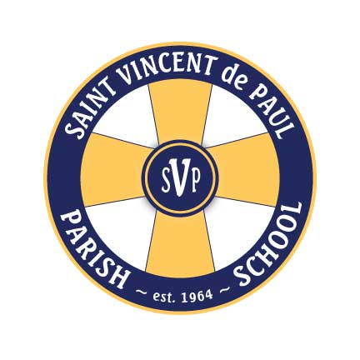

Auction Representative:

Name: _________________________________

Address: _______________________________

_______________________________________

Phone: _________________________________

30527 8th Ave. S., Federal Way, WA 98003

[www.stvs.us](http://www.stvs.us) 253.839.3532

St. Vincent de Paul School

41st Annual Parish Auction for Catholic Education (P.A.C.E.)

59 Years of Excellence in Education: 1964-2023

Dear

We are seeking partners like you who share our passion for the wellbeing of our children and community.

St. Vincent de Paul Parish School is a faith-centered school that promotes academic achievement and spiritual development for our students and families. This is reflected in learning, worship and support of each other and service to the community. Our richly diverse school has been providing academic opportunities for our children in preschool through 8th grade.

The Parish Auction for Catholic Education (P.A.C.E.) is planning its annual fundraising auction to raise funds to maintain academic excellence, and cover operations expenses and cultural experiences for our students.

The generosity of our sponsors and donors over the years has been awe-inspiring, and we continue to count on their tremendous support. We invite you to showcase your business and your commitment to the Federal Way community with your donation and or sponsorship to our auction, “Green and Gold” being held on ***Saturday, March 16, 2024***. Here is how you can help:

**Contribute a quality item (s) or service (s):** Be acknowledged in our auction catalog. Please note that any gift certificates and tickets with an expiration date should be valid for one year from date of the auction.

**Become an event sponsor:** Sponsors receive recognition on our school website and social media pages as well as Media exposure at our Gala and Auction Catalog. In addition to, 2 weeks prior to event you will get constant exposure of you support with logo signage in our carpool and in our weekly newsletter. Please see attached form for our different levels of sponsorships and benefits.

**A simple cash donation to our Fund-a-Need:** Please note checks payable to - St. Vincent de Paul P.A.C.E.

If you are interested in donating to our upcoming auction, please complete the enclosed Sponsorship Form. We are a 501 (C)-(3) non-profit organization and what you choose to donate may be a tax deduction. St. Vincent de Paul Parish School tax identification number is 91-0756413. Please check with your tax advisor for further information.

On behalf of our auction committee, as well as the students of St. Vincent de Paul Parish School, we would like to sincerely thank you for considering a sponsorship, we are always grateful for the opportunity to partner with you.

A parish school forming children to be faith-filled Catholics, to have a joy for learning, and to be responsible members of our community.

Warm Regards,

Auction Representative:

“Green and Gold”

P.A.C.E. 2023-2024